==================================================

Running Genetic Algorithm...

==================================================

==================================================

=== GENETIC ALGORITHM OPTIMIZATION ===

==================================================

[Initialization]

- Population size: 60

- Generations: 40

- Crossover rate: 80%

- Mutation rate: 20%

- Search space: 176 features

- Target: Minimize MSE using XGBoost

[Evolution Progress]

Gen 01/40 | Best MSE: 11389.617206 | Avg MSE: 12455.794315

Gen 06/40 | Best MSE: 11213.547655 | Avg MSE: 11308.956723

Gen 11/40 | Best MSE: 11022.984427 | Avg MSE: 11107.394039

Gen 16/40 | Best MSE: 10940.017894 | Avg MSE: 10988.549778

Gen 21/40 | Best MSE: 10940.017894 | Avg MSE: 10940.017894

Gen 26/40 | Best MSE: 10940.017894 | Avg MSE: 10940.017894

Gen 31/40 | Best MSE: 10940.017894 | Avg MSE: 10940.017894

Gen 36/40 | Best MSE: 10940.017894 | Avg MSE: 10940.017894

Gen 40/40 | Best MSE: 10940.017894 | Avg MSE: 10940.017894

==================================================

=== OPTIMIZATION RESULTS ===

==================================================

▶ Best MSE achieved: 10940.017894

▶ Time elapsed: 1104.67 seconds

▶ Features selected: 102/176 (42.0% reduction)

▶ Selected features:

1. District

2. Neighborhood

3. m² (Gross)

4. Number of rooms

5. Building Age

6. Floor location

7. Number of floors

8. Number of bathrooms

9. Balcony

10. Using status

11. Available for Loan

12. Swap

13. Front West

14. Front South

15. ADSL

16. Smart House

17. Alarm (Thief)

18. Alarm (Fire)

19. Elevator

20. Balcony.1

21. Dishwasher

22. Refrigerator

23. Wall paper

24. Shower

25. Dressing room

26. Closet

27. Video intercom

28. Hilton Bathroom

29. Intercom System

30. Insulating glass

31. Plasterboard

32. Cellar

33. Air conditioning

34. Tub

35. Laminate Floor

36. Marley

37. Furniture

38. Kitchen (Built-in)

39. Kitchen (Laminate)

40. Kitchen Natural Gas

41. Blinds

42. Ceramic Floor

43. Set Top Cooker

44. Spot Lighting

45. Thermosiphon

46. Cloakroom

47. Face Recognition & Fingerprint

48. Washing Machine

49. Washing machine

50. Steel door

51. Fireplace

52. Elevator.1

53. Bath

54. Booster

55. Thermal Insulation

56. Generator

57. Cable TV

58. Closed Garage

59. Doorman

60. Playground

61. Sound insulation

62. Siding

63. Water tank

64. Tennis court

65. Parking Lot

66. Bathroom

67. Wide Corridor

68. Kitchen

69. Park

70. Socket / Electric Switch

71. Handle / Railing

72. Toilet

73. Swimming pool

74. The mall

75. Next to sea shore

76. The church

77. Market

78. Police station

79. Gym

80. Fire Department

81. Highway

82. Bosphorus Bridges

83. Street

84. Sea bus

85. Filled

86. E-5

87. Airport

88. Metro

89. Metrobus

90. Minibus

91. Bus stop

92. Coast

93. TEM

94. Tram

95. Scaffolding

96. Throat

97. Pool

98. City

99. Garage / Shop Top

100. Entrance floor

101. Rerse Duplex

102. Roof Duplex

▶ Convergence progress:

- Initial MSE: 11389.6172

- Final MSE: 10940.0179

- Improvement: 3.9%

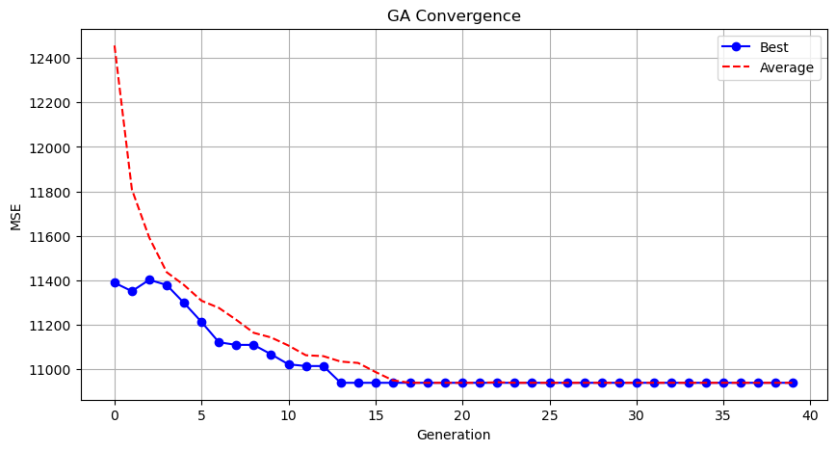

Genetic Algorithm completed successfully with MSE: 10940.0179

==================================================

Running Particle Swarm Optimization...

==================================================

==================================================

=== PARTICLE SWARM OPTIMIZATION ===

==================================================

[Initialization]

- Swarm size: 60 particles

- Iterations: 40

- Cognitive weight: 0.5

- Social weight: 0.5

- Inertia weight: 0.5

- Search space: 176 features

- Target: Minimize MSE using XGBoost

[Optimization Progress]

Stopping search: maximum iterations reached --> 40

==================================================

=== OPTIMIZATION RESULTS ===

==================================================

▶ Best MSE achieved: 11022.286470

▶ Time elapsed: 1044.90 seconds

▶ Features selected: 87/176 (50.6% reduction)

▶ Selected features (with weights):

1. District (weight: 0.927)

2. m² (Gross) (weight: 0.944)

3. m² (Net) (weight: 0.626)

4. Number of rooms (weight: 0.777)

5. Building Age (weight: 0.817)

6. Floor location (weight: 0.963)

7. Number of floors (weight: 0.858)

8. Number of bathrooms (weight: 0.626)

9. Balcony (weight: 0.647)

10. Using status (weight: 0.910)

11. Available for Loan (weight: 0.883)

12. From who (weight: 0.725)

13. Swap (weight: 0.927)

14. Front West (weight: 0.749)

15. Front North (weight: 0.811)

16. Wood Joinery (weight: 0.536)

17. Alarm (Thief) (weight: 0.693)

18. Alarm (Fire) (weight: 0.951)

19. Balcony.1 (weight: 0.627)

20. Refrigerator (weight: 0.545)

21. Parents' Bathroom (weight: 0.705)

22. Dressing room (weight: 0.801)

23. Closet (weight: 0.908)

24. Video intercom (weight: 0.505)

25. Insulating glass (weight: 0.545)

26. Air conditioning (weight: 0.805)

27. Tub (weight: 0.802)

28. Kitchen (Laminate) (weight: 0.956)

29. PVC Joinery (weight: 0.702)

30. Parquet Floor (weight: 0.712)

31. Set Top Cooker (weight: 0.684)

32. Thermosiphon (weight: 0.692)

33. Cloakroom (weight: 0.661)

34. Wi-Fi (weight: 0.536)

35. Face Recognition & Fingerprint (weight: 0.723)

36. Washing Machine (weight: 0.902)

37. Washing machine (weight: 0.558)

38. Steel door (weight: 0.727)

39. Fireplace (weight: 0.926)

40. Elevator.1 (weight: 0.781)

41. Security (weight: 1.000)

42. Generator (weight: 0.934)

43. Cable TV (weight: 0.999)

44. Closed Garage (weight: 0.611)

45. Doorman (weight: 0.722)

46. Nursery (weight: 1.000)

47. With Private Pool (weight: 0.562)

48. Car park (weight: 0.666)

49. Sauna (weight: 0.611)

50. Siding (weight: 0.738)

51. Sports Area (weight: 0.684)

52. Water tank (weight: 0.882)

53. Swimming Pool (Open) (weight: 0.890)

54. Swimming Pool (Indoor) (weight: 0.740)

55. Bathroom (weight: 0.618)

56. Kitchen (weight: 0.542)

57. The mall (weight: 0.604)

58. Cemevi (weight: 0.906)

59. Next to sea shore (weight: 0.919)

60. The church (weight: 0.794)

61. High school (weight: 0.661)

62. The health clinic (weight: 0.646)

63. District Market (weight: 0.766)

64. Unirsity (weight: 0.756)

65. Fire Department (weight: 0.693)

66. Highway (weight: 0.994)

67. Eurasia Tunnel (weight: 0.880)

68. Filled (weight: 0.593)

69. E-5 (weight: 0.959)

70. Metro (weight: 0.869)

71. Metrobus (weight: 0.634)

72. Minibus (weight: 0.955)

73. Bus stop (weight: 0.904)

74. Cable car (weight: 1.000)

75. Tram (weight: 0.549)

76. Railway station (weight: 0.773)

77. Trolley bus (weight: 0.649)

78. Scaffolding (weight: 0.611)

79. Nature (weight: 0.629)

80. Pool (weight: 0.811)

81. Park & ​​Green Area (weight: 0.696)

82. City (weight: 1.000)

83. Garden Duplex (weight: 0.892)

84. Entrance floor (weight: 0.925)

85. Floor Duplex (weight: 0.710)

86. Private Entry (weight: 0.885)

87. Roof Duplex (weight: 0.603)

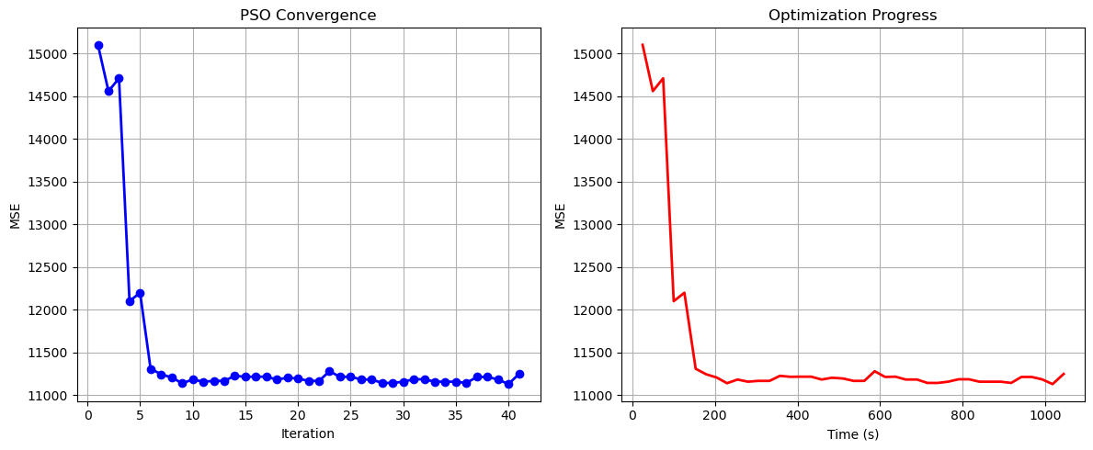

Particle Swarm Optimization completed successfully with MSE: 11022.2865

==================================================

Running Whale Optimization...

==================================================

==================================================

=== WHALE OPTIMIZATION ALGORITHM ===

==================================================

[Initialization]

- Population: 60 whales

- Max iterations: 40

- Spiral coefficient (b): 1.0

- Search space: 176 features

- Target: Minimize MSE using XGBoost

[Optimization Progress]

Iter 40/40 | Best MSE: 11063.349108

==================================================

=== OPTIMIZATION RESULTS ===

==================================================

▶ Best MSE achieved: 11063.349108

▶ Time elapsed: 1408.20 seconds

▶ Features selected: 173/176 (1.7% reduction)

▶ Selected features:

1. District

2. Neighborhood

3. m² (Gross)

4. m² (Net)

5. Number of rooms

6. Building Age

7. Floor location

8. Number of floors

9. Heating

10. Number of bathrooms

11. Balcony

12. Furnished

13. Using status

14. Available for Loan

15. From who

16. Swap

17. Front West

18. Front East

19. Front South

20. Front North

21. ADSL

22. Wood Joinery

23. Smart House

24. Alarm (Thief)

25. Alarm (Fire)

26. Alaturka Toilet

27. Aluminum joinery

28. American Door

29. American kitchen

30. Built-in on

31. Elevator

32. Balcony.1

33. Barbecue

34. Household appliances

35. Painted

36. Dishwasher

37. Refrigerator

38. Wall paper

39. Shower

40. Parents' Bathroom

41. Fiber Internet

42. On

43. Dressing room

44. Closet

45. Video intercom

46. Hilton Bathroom

47. Intercom System

48. Insulating glass

49. Jacuzzi

50. Plasterboard

51. Cellar

52. Air conditioning

53. Tub

54. Laminate Floor

55. Marley

56. Furniture

57. Kitchen (Built-in)

58. Kitchen (Laminate)

59. Kitchen Natural Gas

60. PVC Joinery

61. Blinds

62. Parquet Floor

63. Ceramic Floor

64. Set Top Cooker

65. Spot Lighting

66. Terrace

67. Thermosiphon

68. Cloakroom

69. Wi-Fi

70. Face Recognition & Fingerprint

71. Washing Machine

72. Washing machine

73. Laundry room

74. Steel door

75. Water heater

76. Fireplace

77. Elevator.1

78. Steam room

79. Security

80. Bath

81. Booster

82. Thermal Insulation

83. Generator

84. Cable TV

85. Closed Garage

86. Doorman

87. Nursery

88. With Private Pool

89. Car park

90. Playground

91. Sauna

92. Sound insulation

93. Siding

94. Water tank

95. Tennis court

96. Satellite

97. Fire escape

98. Swimming Pool (Indoor)

99. Parking Lot

100. Elevator.2

101. Bathroom

102. Wide Corridor

103. Entrance / Ramp

104. Stairs

105. Kitchen

106. Room door

107. Park

108. Socket / Electric Switch

109. Handle / Railing

110. Toilet

111. Swimming pool

112. The mall

113. municipality

114. Mosque

115. Cemevi

116. Next to sea shore

117. Pharmacy

118. Amusement center

119. Fair

120. Hospital

121. Synagogue

122. The church

123. High school

124. Market

125. Park.1

126. Police station

127. The health clinic

128. District Market

129. Gym

130. Unirsity

131. Primary School-Secondary School

132. Fire Department

133. Town center

134. Highway

135. Eurasia Tunnel

136. Bosphorus Bridges

137. Street

138. Sea bus

139. E-5

140. Airport

141. Marmaray

142. Metro

143. Metrobus

144. Minibus

145. Bus stop

146. Coast

147. TEM

148. Cable car

149. Tram

150. Railway station

151. Trolley bus

152. Scaffolding

153. Throat

154. Sea

155. Nature

156. Lake

157. Pool

158. Park & ​​Green Area

159. City

160. Mezzanine

161. Mezzanine Duplex

162. Garden Duplex

163. Garden Floor

164. Garden

165. Top floor

166. Garage / Shop Top

167. Entrance floor

168. Floor Duplex

169. Private Entry

170. Rerse Duplex

171. Triplex

172. Ground floor

173. Roof Duplex

▶ Convergence progress:

- Initial MSE: 16397.7041

- Final MSE: 11063.3491

- Improvement: 32.5%

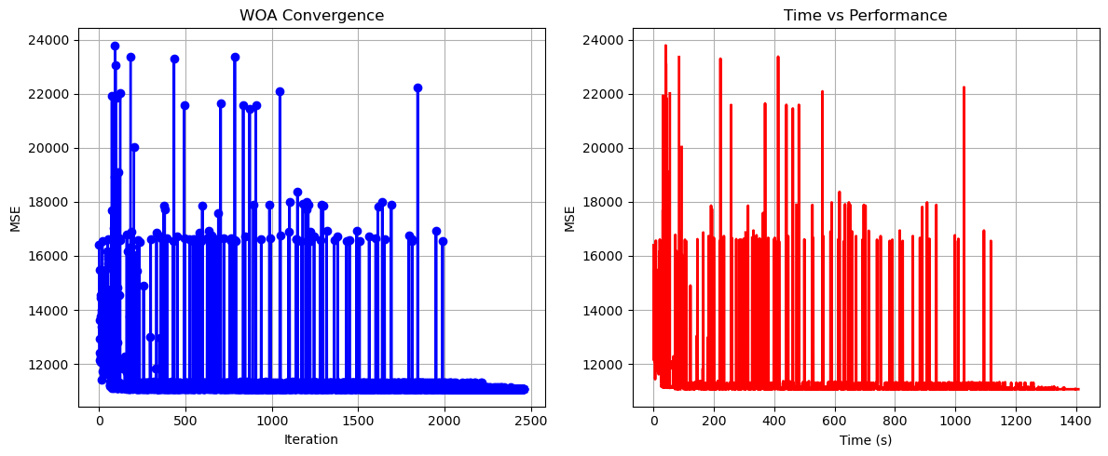

Whale Optimization completed successfully with MSE: 11063.3491

==================================================

Running Squid Game Optimizer...

==================================================

==================================================

=== SQUID GAME OPTIMIZER (SGO) ===

==================================================

[Initialization]

- Players: 60 (30 offensive, 30 defensive)

- Max games: 40

- Search space: 176 features

- Target: Minimize MSE using XGBoost

==================================================

=== OPTIMIZATION RESULTS ===

==================================================

▶ Best MSE achieved: 10939.258387

▶ Time elapsed: 923.80 seconds

▶ Features selected: 71/176 (59.7% reduction)

▶ Selected features:

1. District

2. Neighborhood

3. m² (Gross)

4. Number of rooms

5. Building Age

6. Floor location

7. Number of floors

8. Heating

9. Number of bathrooms

10. Balcony

11. Using status

12. Available for Loan

13. Front North

14. Wood Joinery

15. Smart House

16. Alaturka Toilet

17. American Door

18. Built-in on

19. Elevator

20. Refrigerator

21. Wall paper

22. Fiber Internet

23. On

24. Intercom System

25. Insulating glass

26. Tub

27. Laminate Floor

28. Marley

29. Furniture

30. Kitchen (Laminate)

31. Ceramic Floor

32. Set Top Cooker

33. Thermosiphon

34. Face Recognition & Fingerprint

35. Fireplace

36. Security

37. Generator

38. Cable TV

39. Closed Garage

40. With Private Pool

41. Car park

42. Playground

43. Tennis court

44. Swimming Pool (Indoor)

45. Elevator.2

46. Toilet

47. Swimming pool

48. The mall

49. Next to sea shore

50. Pharmacy

51. Amusement center

52. Fair

53. The health clinic

54. District Market

55. Gym

56. Unirsity

57. Primary School-Secondary School

58. Town center

59. Eurasia Tunnel

60. Bosphorus Bridges

61. Street

62. E-5

63. Marmaray

64. Railway station

65. Trolley bus

66. Throat

67. Nature

68. Garden Duplex

69. Top floor

70. Rerse Duplex

71. Ground floor

▶ Convergence progress:

- Initial MSE: 11093.0200

- Final MSE: 10939.2584

- Improvement: 1.4%

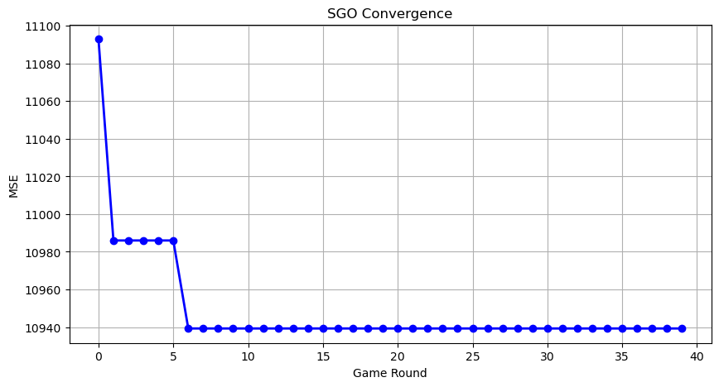

Squid Game Optimizer completed successfully with MSE: 10939.2584

==================================================

Running PSH-Hyptrite...

==================================================

==================================================

=== PSH-HYPTRITE OPTIMIZATION ===

==================================================

[Initialization]

- Search points: 60

- Max iterations: 40

- Initial radius: 0.5 (adaptive)

- Hypersphere samples: 3 per point

- Search space: 176 features

- Target: Minimize MSE using XGBoost

[Optimization Progress]

Iter 40/40 | Best MSE: 11050.233424 | Radius: 0.0125

==================================================

=== OPTIMIZATION RESULTS ===

==================================================

▶ Best MSE achieved: 11050.233424

▶ Time elapsed: 3111.95 seconds

▶ Features selected: 93/176 (47.2% reduction)

▶ Selected features (with weights):

1. District (weight: 0.629)

2. Neighborhood (weight: 0.658)

3. m² (Gross) (weight: 0.992)

4. m² (Net) (weight: 0.902)

5. Number of rooms (weight: 0.621)

6. Building Age (weight: 0.853)

7. Floor location (weight: 0.529)

8. Number of floors (weight: 0.808)

9. Heating (weight: 0.599)

10. Number of bathrooms (weight: 0.649)

11. Using status (weight: 0.797)

12. Front West (weight: 0.879)

13. Front East (weight: 0.598)

14. Front North (weight: 1.000)

15. Wood Joinery (weight: 0.618)

16. Smart House (weight: 0.890)

17. Alarm (Fire) (weight: 0.850)

18. Aluminum joinery (weight: 0.658)

19. American Door (weight: 0.551)

20. Built-in on (weight: 0.857)

21. Barbecue (weight: 0.606)

22. Dishwasher (weight: 0.523)

23. Wall paper (weight: 0.699)

24. Shower (weight: 0.917)

25. Fiber Internet (weight: 0.741)

26. On (weight: 0.796)

27. Video intercom (weight: 0.802)

28. Intercom System (weight: 0.729)

29. Jacuzzi (weight: 0.936)

30. Cellar (weight: 0.657)

31. Air conditioning (weight: 0.734)

32. Tub (weight: 1.000)

33. Marley (weight: 0.906)

34. Kitchen (Built-in) (weight: 0.568)

35. Kitchen Natural Gas (weight: 0.901)

36. Blinds (weight: 0.793)

37. Ceramic Floor (weight: 0.739)

38. Set Top Cooker (weight: 0.605)

39. Cloakroom (weight: 0.745)

40. Wi-Fi (weight: 0.794)

41. Face Recognition & Fingerprint (weight: 0.755)

42. Laundry room (weight: 0.528)

43. Steel door (weight: 0.932)

44. Water heater (weight: 0.991)

45. Elevator.1 (weight: 0.590)

46. Steam room (weight: 0.945)

47. Security (weight: 0.544)

48. Booster (weight: 0.747)

49. Thermal Insulation (weight: 0.698)

50. Cable TV (weight: 1.000)

51. Doorman (weight: 0.684)

52. With Private Pool (weight: 0.504)

53. Siding (weight: 0.683)

54. Sports Area (weight: 0.886)

55. Water tank (weight: 0.787)

56. Satellite (weight: 0.893)

57. Entrance / Ramp (weight: 0.731)

58. Kitchen (weight: 0.627)

59. Toilet (weight: 0.998)

60. municipality (weight: 0.734)

61. Fair (weight: 0.771)

62. Synagogue (weight: 0.906)

63. The church (weight: 0.716)

64. Market (weight: 0.980)

65. Park.1 (weight: 0.608)

66. Police station (weight: 0.578)

67. The health clinic (weight: 0.944)

68. District Market (weight: 0.615)

69. Gym (weight: 0.667)

70. Unirsity (weight: 0.945)

71. Primary School-Secondary School (weight: 0.645)

72. Fire Department (weight: 1.000)

73. Eurasia Tunnel (weight: 0.862)

74. Street (weight: 0.970)

75. Filled (weight: 0.815)

76. E-5 (weight: 0.542)

77. Airport (weight: 0.852)

78. Marmaray (weight: 0.569)

79. Metro (weight: 0.763)

80. Scaffolding (weight: 0.990)

81. Sea (weight: 0.754)

82. Lake (weight: 0.562)

83. Pool (weight: 0.949)

84. City (weight: 0.554)

85. Mezzanine (weight: 0.595)

86. Mezzanine Duplex (weight: 0.655)

87. Garden Duplex (weight: 0.888)

88. Garden (weight: 0.703)

89. Top floor (weight: 0.715)

90. Garage / Shop Top (weight: 0.654)

91. Floor Duplex (weight: 0.741)

92. Triplex (weight: 0.502)

93. Roof Duplex (weight: 1.000)

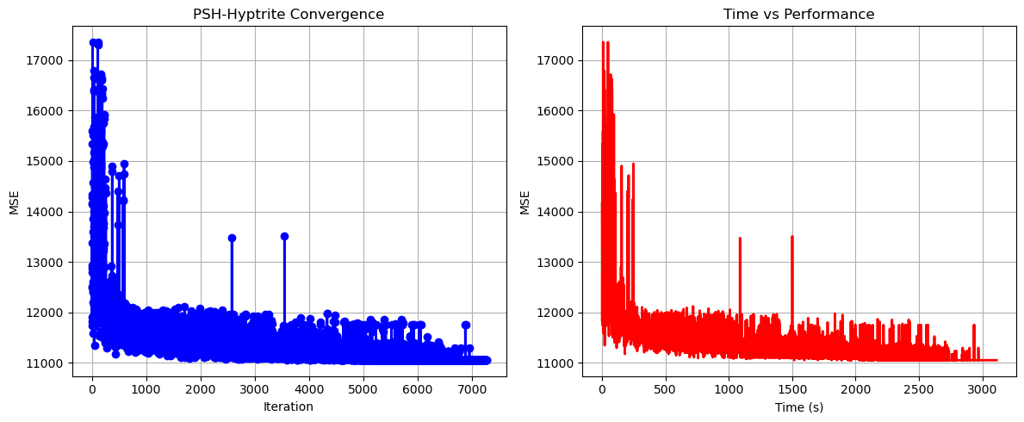

PSH-Hyptrite completed successfully with MSE: 11050.2334

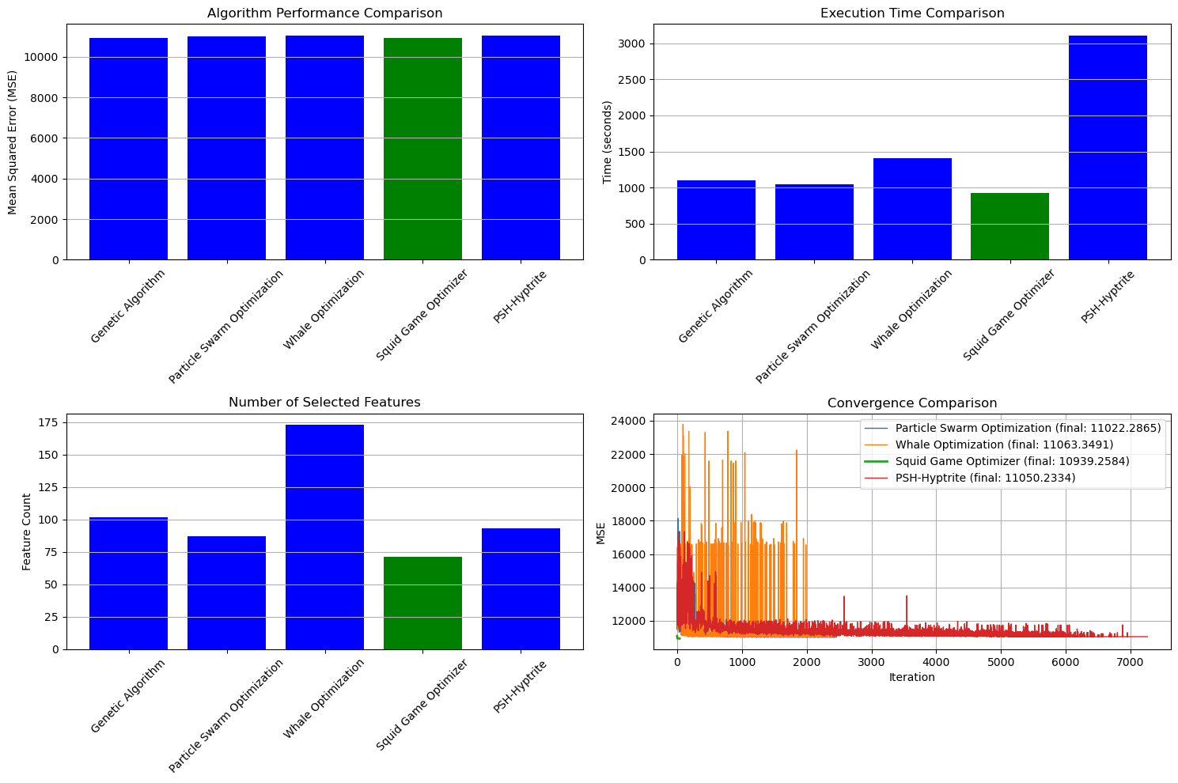

==================================================

FINAL RESULTS SUMMARY

==================================================

🏆 Best Algorithm: Squid Game Optimizer

📉 Best MSE Achieved: 10939.258387

⏱️ Execution Time: 923.80 seconds

🔢 Features Selected: 71

Selected Features:

1. District

2. Neighborhood

3. m² (Gross)

4. Number of rooms

5. Building Age

6. Floor location

7. Number of floors

8. Heating

9. Number of bathrooms

10. Balcony

11. Using status

12. Available for Loan

13. Front North

14. Wood Joinery

15. Smart House

16. Alaturka Toilet

17. American Door

18. Built-in on

19. Elevator

20. Refrigerator

21. Wall paper

22. Fiber Internet

23. On

24. Intercom System

25. Insulating glass

26. Tub

27. Laminate Floor

28. Marley

29. Furniture

30. Kitchen (Laminate)

31. Ceramic Floor

32. Set Top Cooker

33. Thermosiphon

34. Face Recognition & Fingerprint

35. Fireplace

36. Security

37. Generator

38. Cable TV

39. Closed Garage

40. With Private Pool

41. Car park

42. Playground

43. Tennis court

44. Swimming Pool (Indoor)

45. Elevator.2

46. Toilet

47. Swimming pool

48. The mall

49. Next to sea shore

50. Pharmacy

51. Amusement center

52. Fair

53. The health clinic

54. District Market

55. Gym

56. Unirsity

57. Primary School-Secondary School

58. Town center

59. Eurasia Tunnel

60. Bosphorus Bridges

61. Street

62. E-5

63. Marmaray

64. Railway station

65. Trolley bus

66. Throat

67. Nature

68. Garden Duplex

69. Top floor

70. Rerse Duplex

71. Ground floor

[ ]:

[ ]: